Project Design Document

1. Design Intent
- We are trying to recreate the HOGWARTS experience – a real-life simulation of being in harry potter’s world.
- It is designed to feel the experience of being at Hogwarts school of magic – those who have unlived dreams of experiencing magic, and potterheads of course, would especially love this project

2. Inspiration & References
- Harry Potter (the movie scenes)
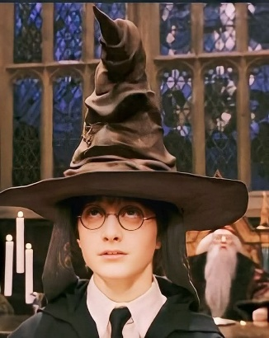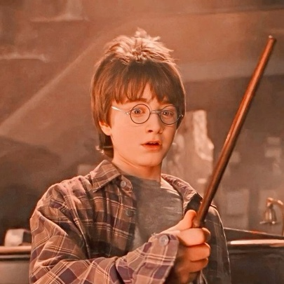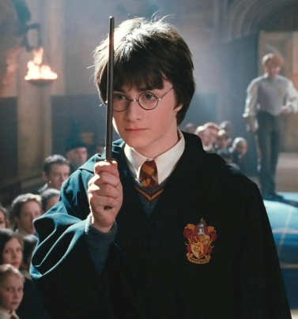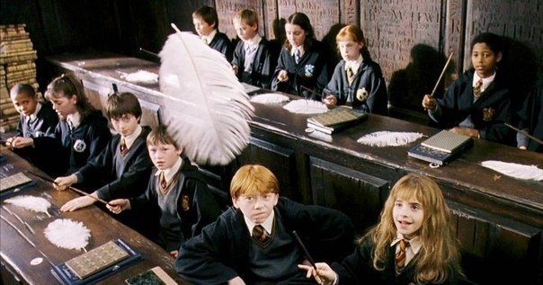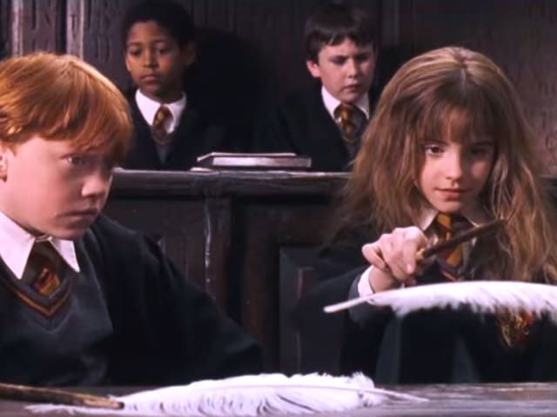
- We understood how to recreate the exact experiences – The Sorting Hat scene, the Wand Selection scene, and the Floating Objects Scene. Then, we put in our own interpretations and customized it accordingly to our project.

3. User Journey
Step-by-step experience of the user:
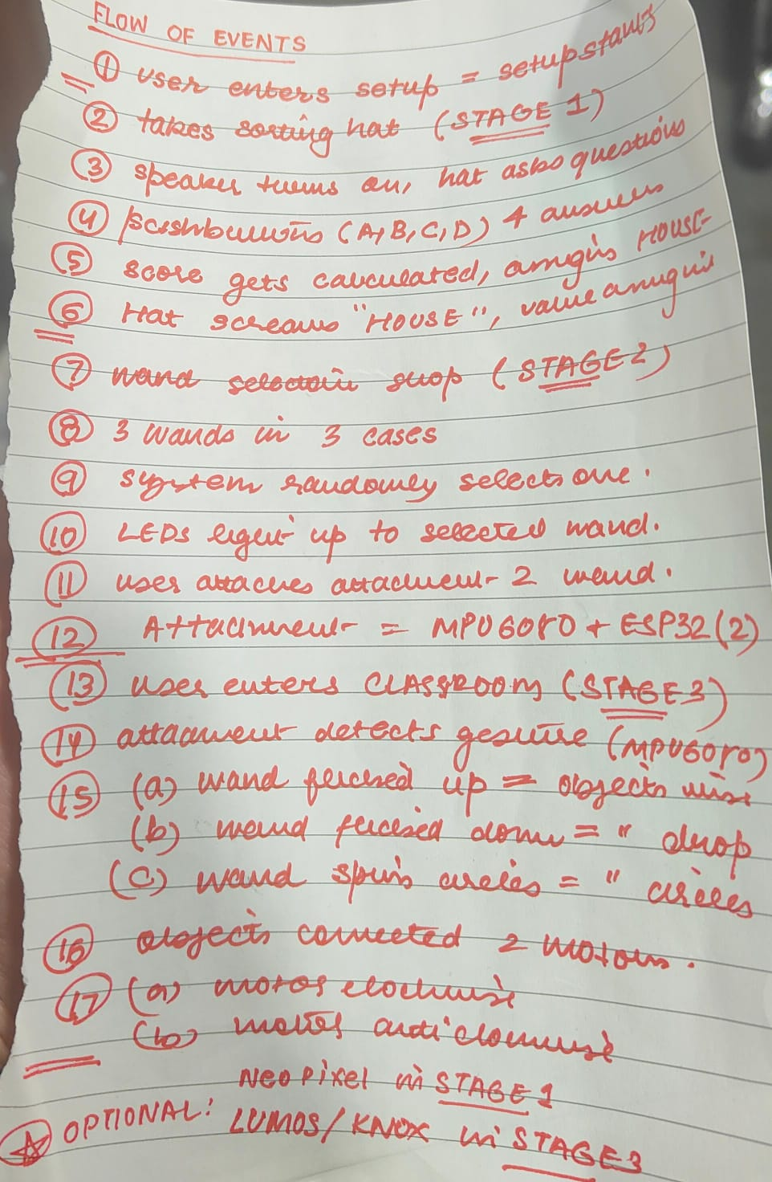
👉 Think like storytelling

4. Success Criteria
Define measurable success:
- Functional (e.g., Sorting Hat voice is clearly audible, push buttons input working correctly, calculating points efficiently, sorting into a house accordingly, neopixels lighting up randomly, the wireless ESP32 and MHU6050 working properly, the motions being sensed correctly, DC motors spinning fast and efficiently to create a pulley system)
- User experience (easy to use and understand, surprised and excited)
- A streamlined experience

5. System Overview
- High-level explanation of system
- The system is built using two ESP32 microcontrollers that communicate wirelessly to create an interactive, multi-stage experience. The primary board (ESP32 P) controls the overall flow, including the Sorting Hat quiz, wand selection using NeoPixel rings, and motor-driven object movement. The secondary board (ESP32 Z) is embedded inside the wand and uses an MPU6050 sensor to detect motion and gestures such as tilting and circular movement.
- In the first stage, the Sorting Hat quiz is conducted using a DFPlayer Mini module connected to a speaker. Pre-recorded audio questions are played, and the user responds using push buttons. Each response contributes to a scoring system that determines the final house, which is then announced through the speaker. This stage integrates audio playback, input handling, and decision logic.
- The second stage focuses on wand selection using three NeoPixel rings. Initially, all rings glow softly, and once the stage begins, they animate to create a premium selection effect. One wand is randomly chosen, and its corresponding ring highlights in a distinct color, guiding the user toward their assigned wand.
- In the third stage, gesture-based interaction is enabled. The ESP32 inside the wand continuously reads accelerometer and gyroscope data from the MPU6050 sensor. Based on the wand’s orientation and motion, it classifies actions such as lifting, dropping, or spinning. These actions are transmitted wirelessly using ESP-NOW to the main ESP32, which then controls DC motors to create the illusion of floating or moving objects in the environment.

6. High-Level Block Diagram
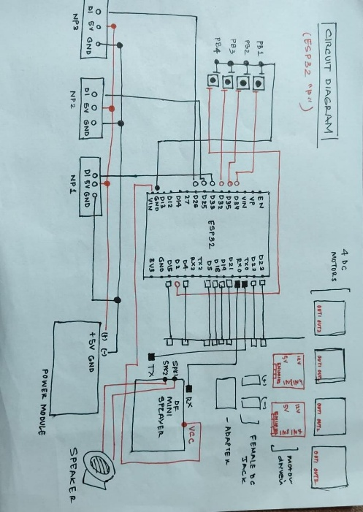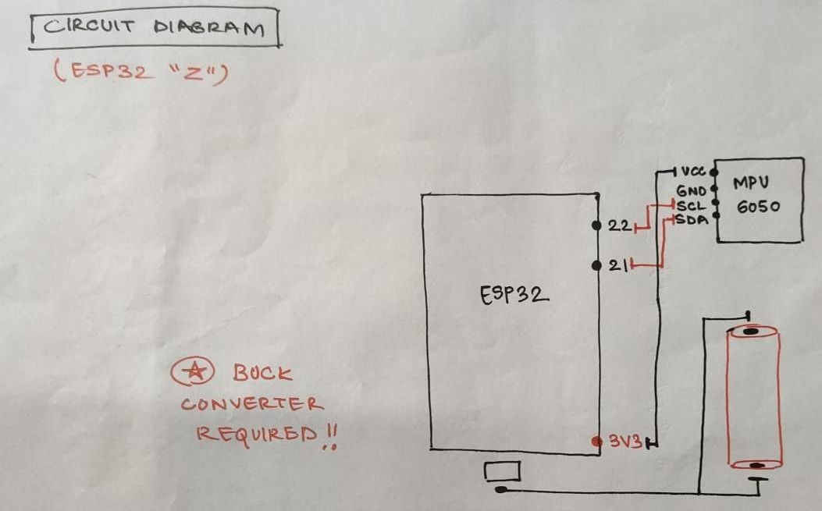
👉 Visual diagram of system components and flow

7. Input / Output Mapping
Input | Process | Output
The experience has begun. User puts on the sorting hat. | The sorting hat has a speaker and DFPlayer connected. The MP3 has an amplifier. The questions are now asked. | The pre-recorded questions are now heard. Users move through the personality quiz and answer the questions
Push buttons for answers after the Sorting Hat asks questions | Answers have allocated points. The system calculates these to announce a final house. | The sorting hat voice announces the house decided by the points.
(User moves to the second (wand) stage) | After the house is announced, the wand stage beings. The 3 neopixels are white in color and one is selected randomly. | The randomly selected one changes to gold color. This indicates the matching wand as ‘the chosen wand’.
The user takes the wand and adds the wireless ESP32 and MHU6050 attachment. The user flicks their hand upwards and downwards. | Motion is detected. This indicates the pulley system is about to start using the DC motors that are connected. | The DC motors start winding the thread upwards. The attached objects are pulled upward as a result, giving the ‘floating objects’ illusion.

8. Sketches & Concepts
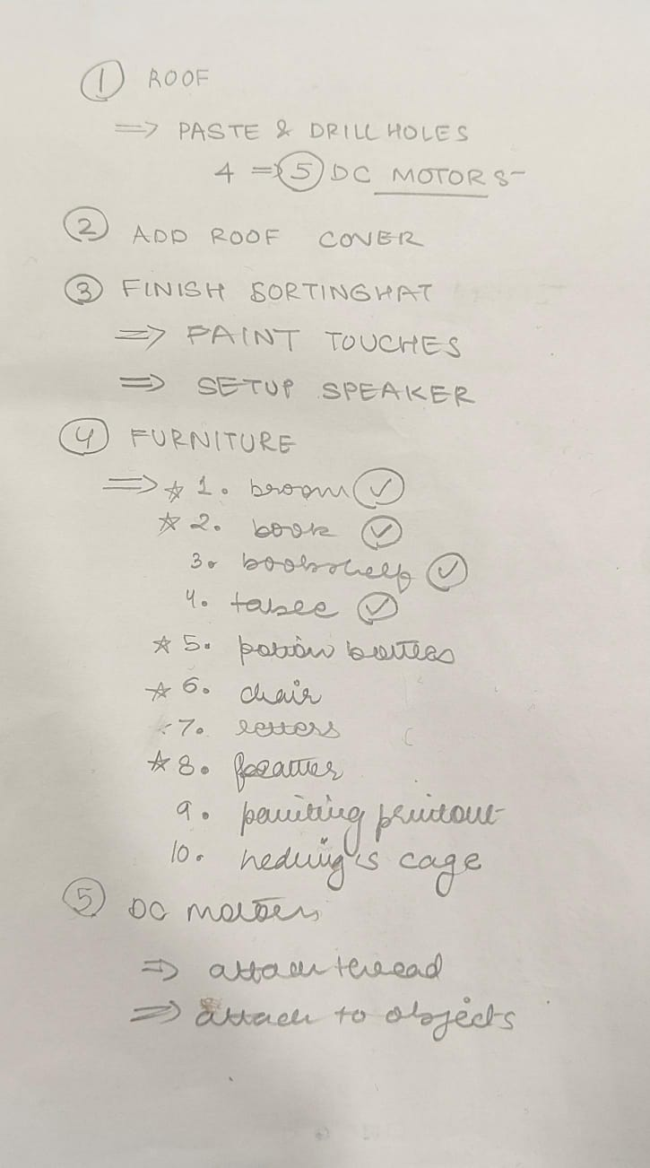

9. Final System Architecture (Labelled)
Done above.
👉 Clear diagram showing all components and connections

